COVID Vaccination Practice Communication for website/social media
GP surgeries in the Grantham and Sleaford area have been working together to deliver the Covid-19 vaccination campaign since mid-December 2020. This has been hugely successful up to now, with just short of 40,000 vaccinations administered at the main vaccination centre running at The Meres Leisure Centre in Grantham, in nursing and residential care homes, to our housebound patients and also at ‘pop-up’ sessions in the Sleaford area for those patients unable to travel to Grantham.
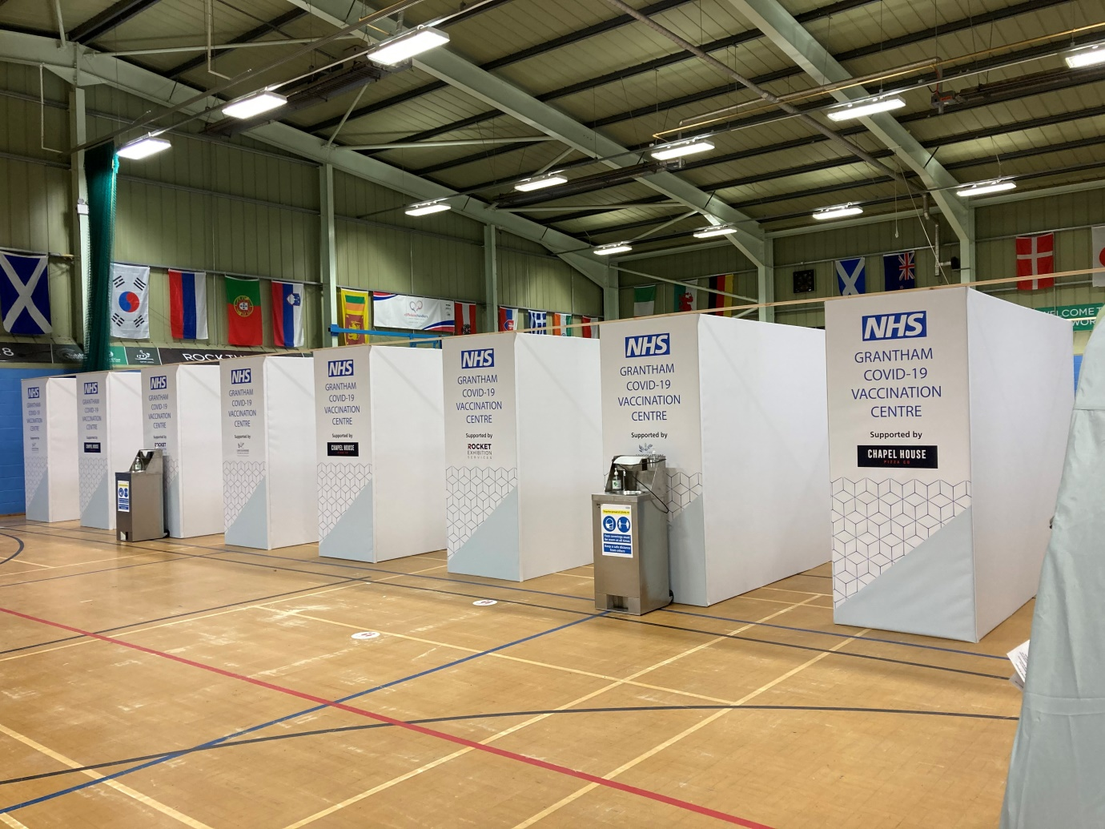
The team at The Meres Leisure Centre, which includes lots of amazing local volunteers, have the ability to administer 2 vaccinations every minute! And all from our state of the art, custom-built 9-lane ‘Super Highway’
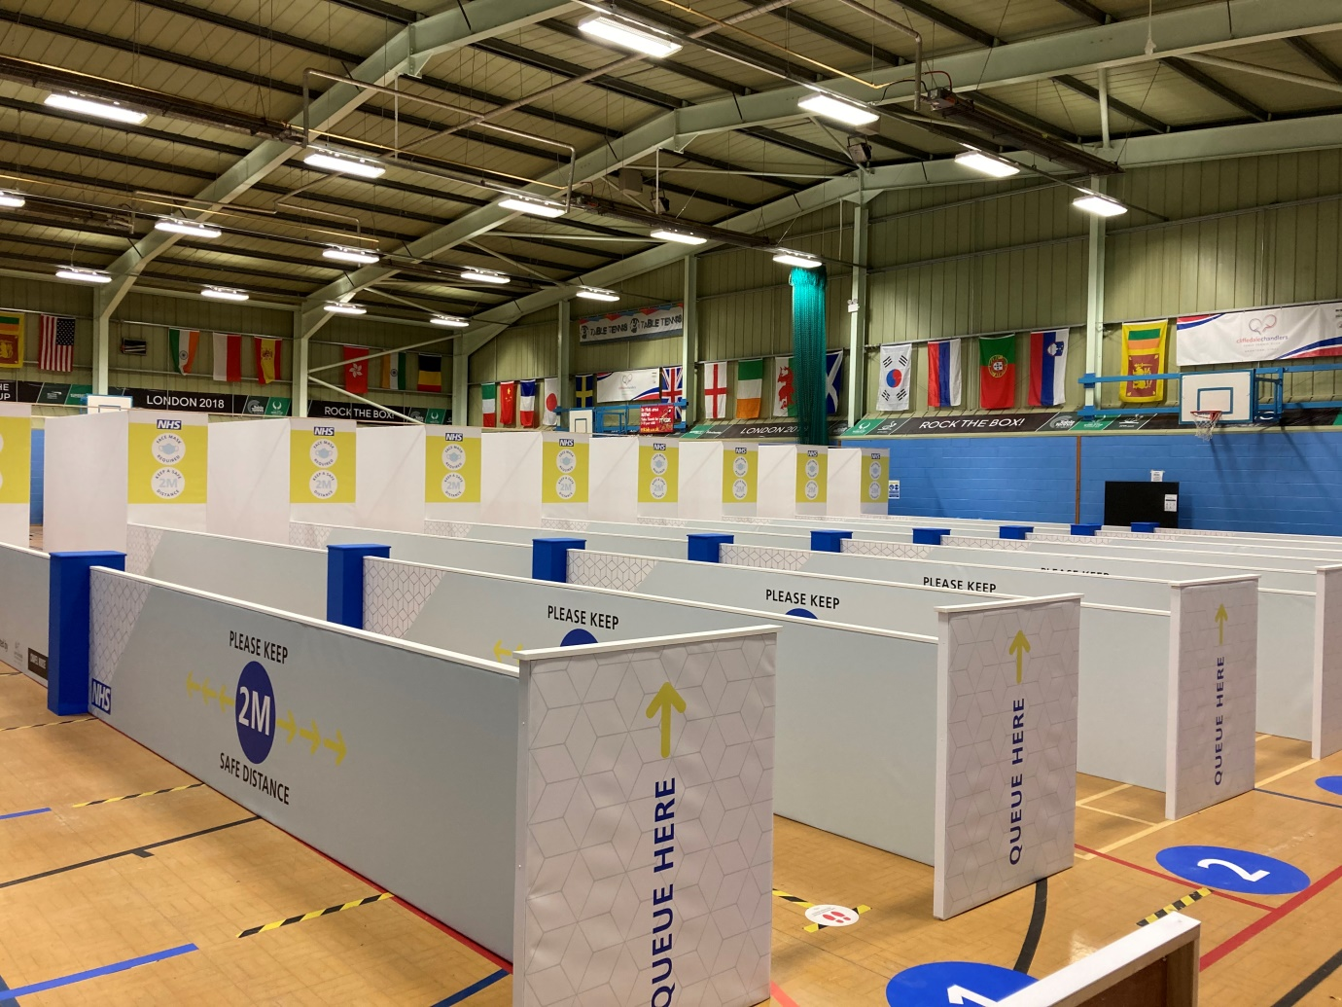
The feedback that we are hearing from those that have received their vaccination has been overwhelmingly positive, with patients thrilled by how quickly they receive the vaccination from the friendly and efficient team. Most people have had their jab within 7.5 minutes, on average, from arriving at the centre!
The Prime Minister set an ambitious target of offering a vaccination appointment to all patients in the first 4 priority cohorts by the 15th February this year, and we are delighted to say that we exceeded that target in the Grantham & Sleaford area. Practices are now working through the next group of priority patients and invitations are sent, usually via a text message link so it’s really important to ensure that you update your contact details. Don’t worry, you will be contacted by your practice so please don’t be concerned if you don’t have the technology to book an appointment this way. We won’t be leaving anyone behind!
Some of you may have received letters inviting you to book your vaccination appointment at one of the county mass vaccination centres. We are planning to accommodate you locally very soon so please don’t feel you need to travel to Boston or Lincoln. We are experiencing a bit of a lull in vaccine supply at the moment, but are hopeful that this will be rectified in the coming days so that your local vaccination centre at The Meres in Grantham will be able to welcome you shortly. Your GP surgery will be contacting you as soon as they can once vaccine deliveries are confirmed.

