|  |  |  |  |  |  |  |  |  |
| --- | --- | --- | --- | --- | --- | --- | --- | --- |
| **For further information please go to our** askmyGP **section or**  [**http://www.thewelbypractice.co.uk/info.aspx?**](http://www.thewelbypractice.co.uk/info.aspx?p=18)  Alternatively if you do not have an email address please do not hesitate to contact us by telephone where a member of our reception team will help with any queries and askmyGP requests. | |  | [AskmyGP](https://my.askmygp.uk/?c=C82076) | | [AskmyGP](https://my.askmygp.uk/?c=C82076)  **Faster, easier access to your GP surgery**  [www.thewelbypractice.co.uk](http://www.thewelbypractice.co.uk)  **For further information please go to our** askmyGP **section on**  [**http://www.thewelbypractice.co.uk/info.aspx?**](http://www.thewelbypractice.co.uk/info.aspx?p=18)  **Guide to online:** | | | |
|  | |  |
|  | Belvoir Vale  17a Walford Close  Bottesford  Nottinghamshire  NG13 0AN  01949 842341 |  | Bescaby Lane  Waltham  Melton Mowbray  Leicestershire  LE14 4AB  01664 464232  Swine Hill  Harlaxton  Grantham  Lincolnshire  NG32 1HT  01476 563881 | |  |  | | |
| **Page 1**  **Page 6**  The Welby Practice | | | | | | | | | |
| **Page**  1-2  3  4  5-6  **Select who the request is for either clicking patient if for yourself or click parent or carer if it is for someone who you care for. If selecting someone you care for you will need to select their name on the next screen.**  **Contents:**  How to register online for askmyGP  How to register online for askmyGPwhen receiving a welcome email  How to use askmyGP as an existing user  How to make a new request on askmyGP  as an existing user | | | | | | | | | |
| **How to register online for askmyGP**  **From any computer, tablet or smart phone go to our practice website** [**www.thewelbypractice.co.uk**](http://www.thewelbypractice.co.uk) **and click the link from the home page for askmyGP.**      **Then click consult your GP**  [AskmyGP](https://my.askmygp.uk/?c=C82076) | | | | | [AskmyGP](https://my.askmygp.uk/?c=C82076)      **From here follow the questions by clicking the relevant options. Once all questions are answered press send and await your reply from a clinician. Please note those requesting face to face appointments may be emailed/telephoned first to establish if a face to face appointment is necessary.** | | |  | |
| The Welby Pracitce  **Page 5**  **Page 2**  **How to make a new request on askmyGP as an existing user**  **Click new request**  [AskmyGP](https://my.askmygp.uk/?c=C82076)  **Then click consult your GP** | | | | | **Then click sign up as a new user**    **Now complete the registration form and click confirm**  [AskmyGP](https://my.askmygp.uk/?c=C82076) | | |  |

The Welby Practice

**Page 3**

**Page 4**

ATTENTION

GRABBER

**How to register online for askmyGP after receiving a welcome email**

**To receive a welcome emails please contact the surgery**

**How to use askmygp as an existing user**

**Access askmyGP by logging onto** [**www.thewelbypractice.co.uk**](http://www.thewelbypractice.co.uk) **and clicking the askmyGP logo on the home page from any computer, tablet or smart phone.**

**Then in the top right hand corner press login and enter your details.**

**Open the email you have received from askmyGP and click create new password**

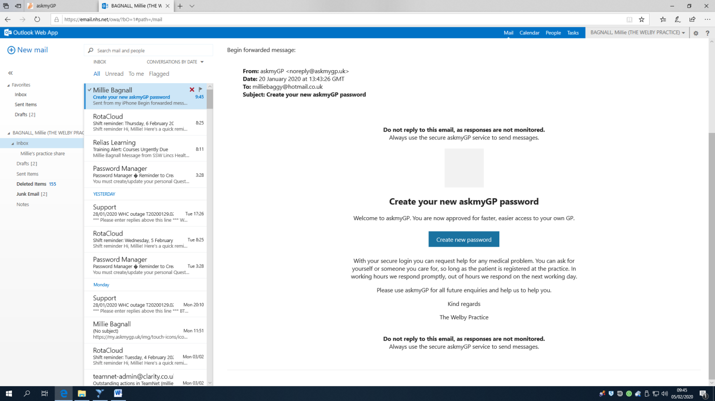

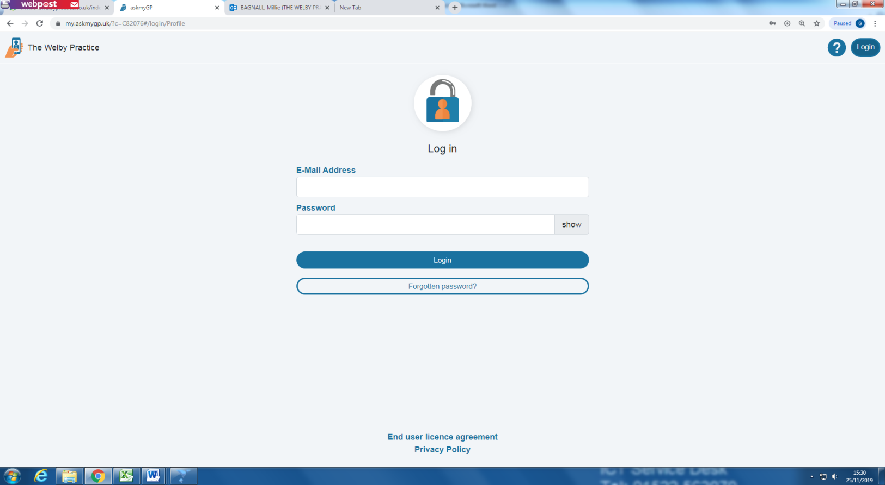

**Enter your E-mail Address, Date of Birth and the password of your choice in the relevant boxes. Then click reset password. You are now a registered user on askmyGP. You can use your email address and password to log back in.**

**From here you can create a new request, view previous requests, edit your details, see when your GP is working and see/add patients you care for.**

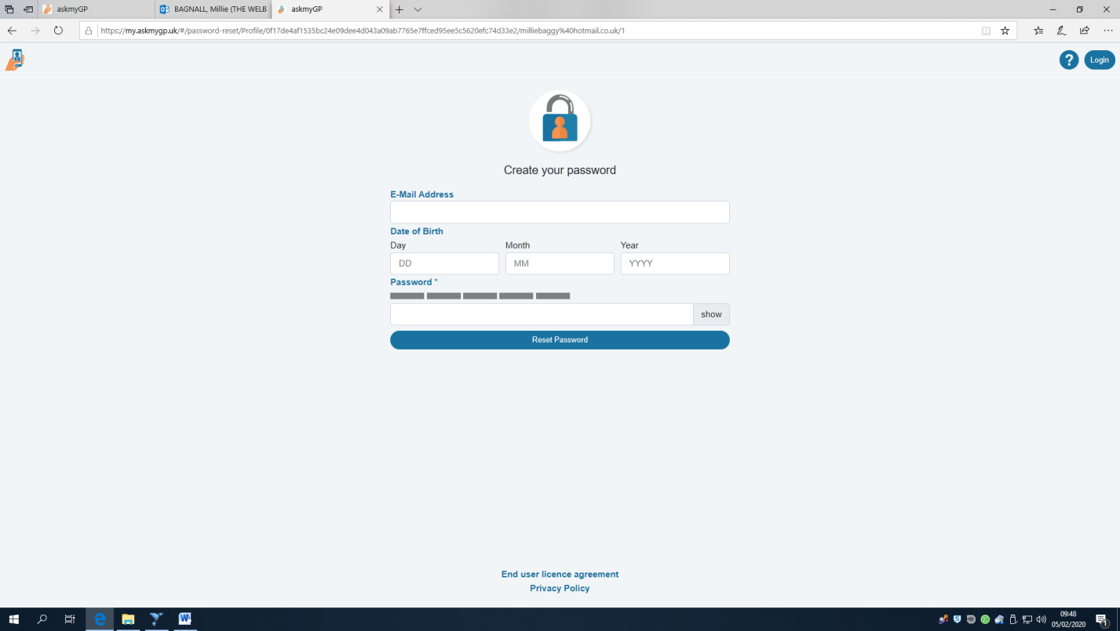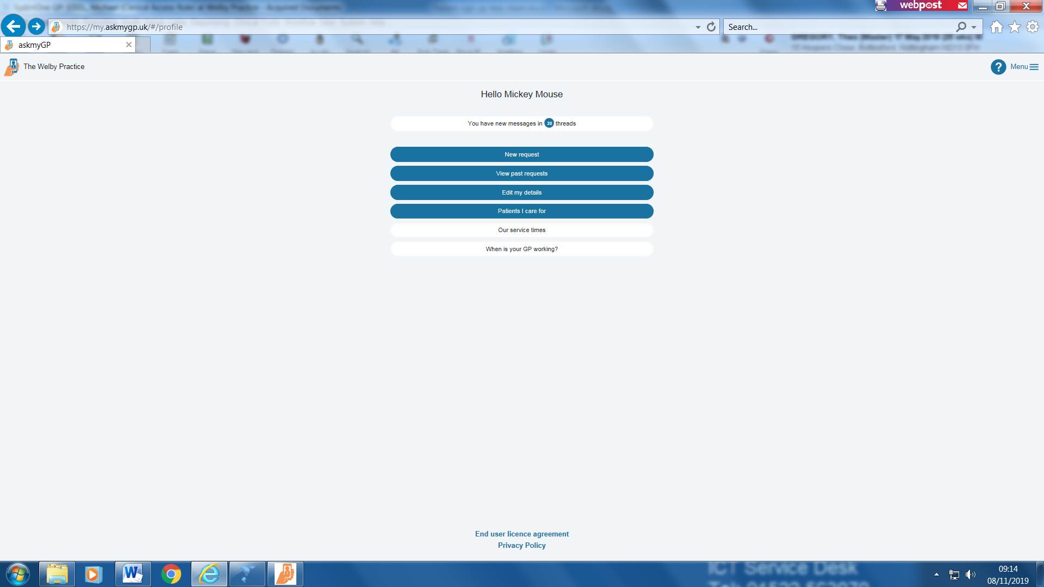

[AskmyGPAskmyGP](https://my.askmygp.uk/?c=C82076)